**GOOGLE AXE TOOL**

axe DevTools - Web Accessibility Testing:

* Accessibility Checker for Developers, Testers, and Designers in Chrome
* Find and fix more accessibility issues during website development with axe DevTools.
* The free axe DevTools browser extension is a fast, lightweight, yet powerful testing tool driven by the world’s most trusted accessibility testing engine, axe-core, developed by Deque.
* The free axe DevTools browser extension is ideal for development teams to test your web applications to help identify and resolve common accessibility issues.
* It’s simple to use, doesn’t require advanced accessibility knowledge and won’t waste your time with false positives.
* Go to Chrome 🡪 Search google axe tool.

https://chrome.google.com/webstore/detail/axe-devtools-web-accessib/lhdoppojpmngadmnindnejefpokejbdd

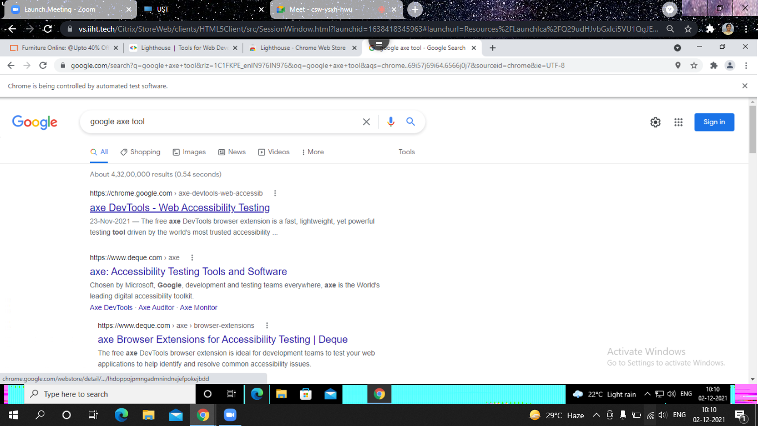

* Add extension to chrome.

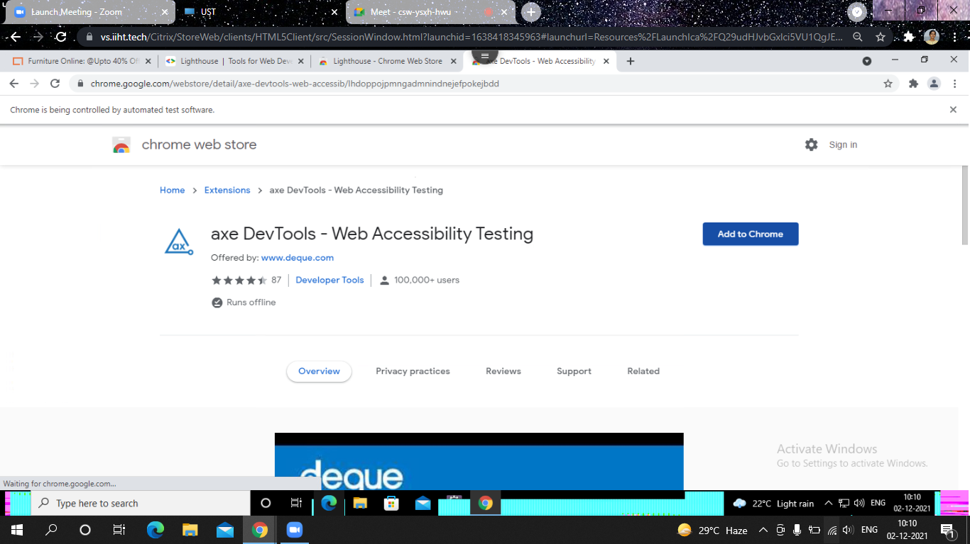

* Take urbanladder website https://www.urbanladder.com/
* Click **axe DevTools** from inspect section of the corresponding website.

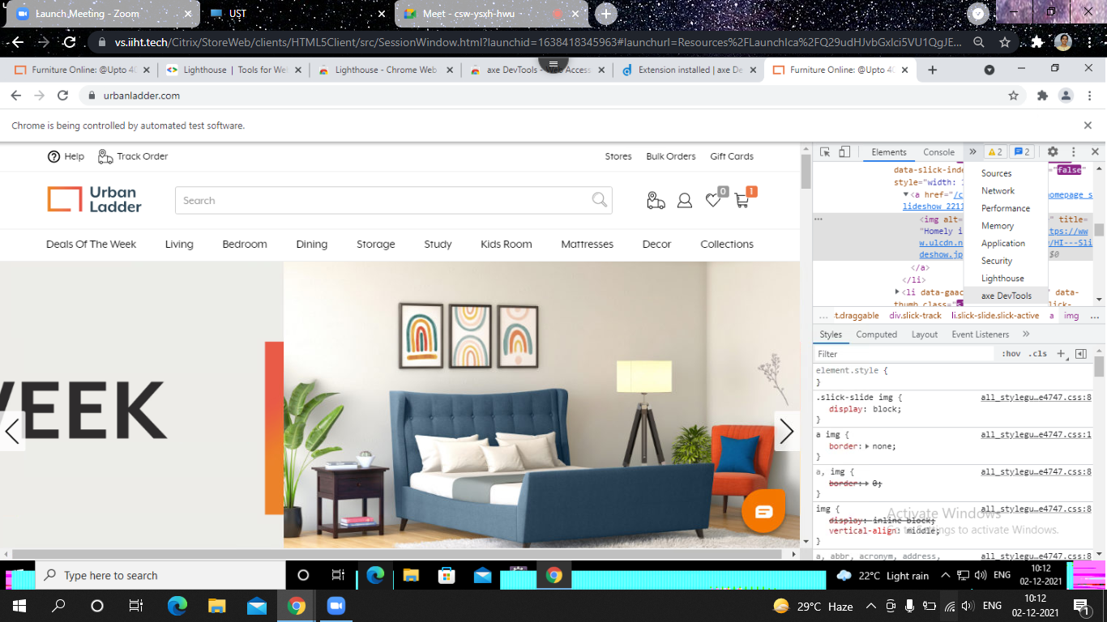

* Select the role of your choice.
* Accept the terms & conditions.
* Then click start.

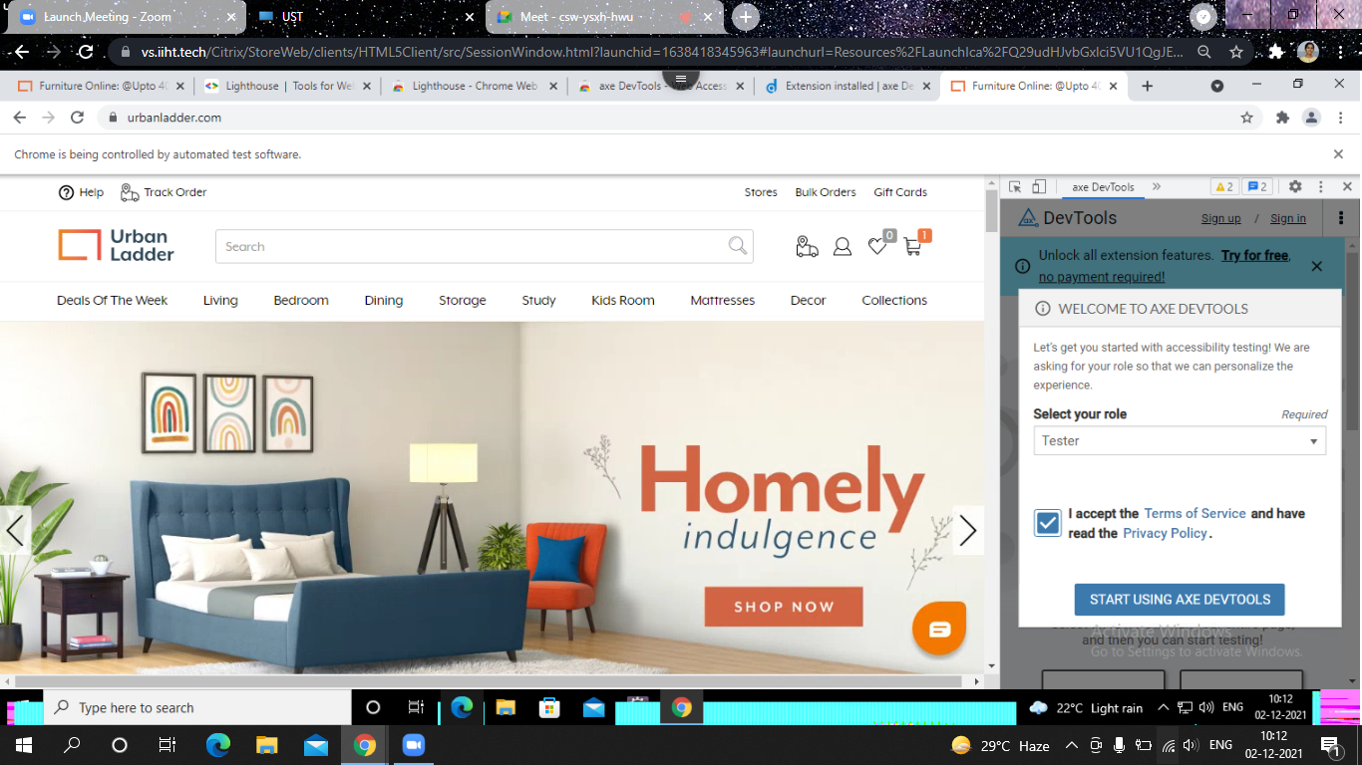

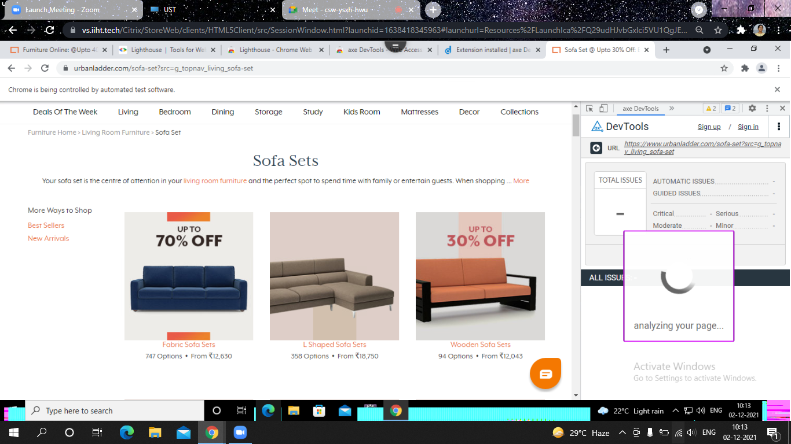

* Below shows the total issues in that site.

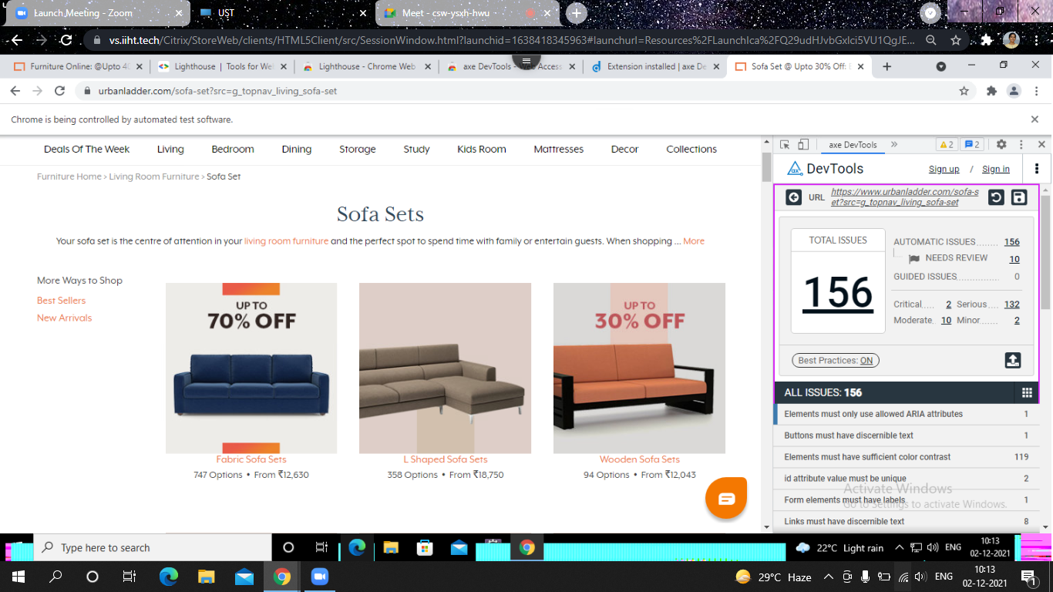

* Detected 156 issues in the given website.

